Network Address Translation Configuration
College of Science, Engineering, and Technology, Grand Canyon University
ITT-216: Enterprise Route & Switch
Instructor Tim Collins
Liela Pressley
5/10/2023

- Created and connected an ISP router to the Main Routeer via Serial Connection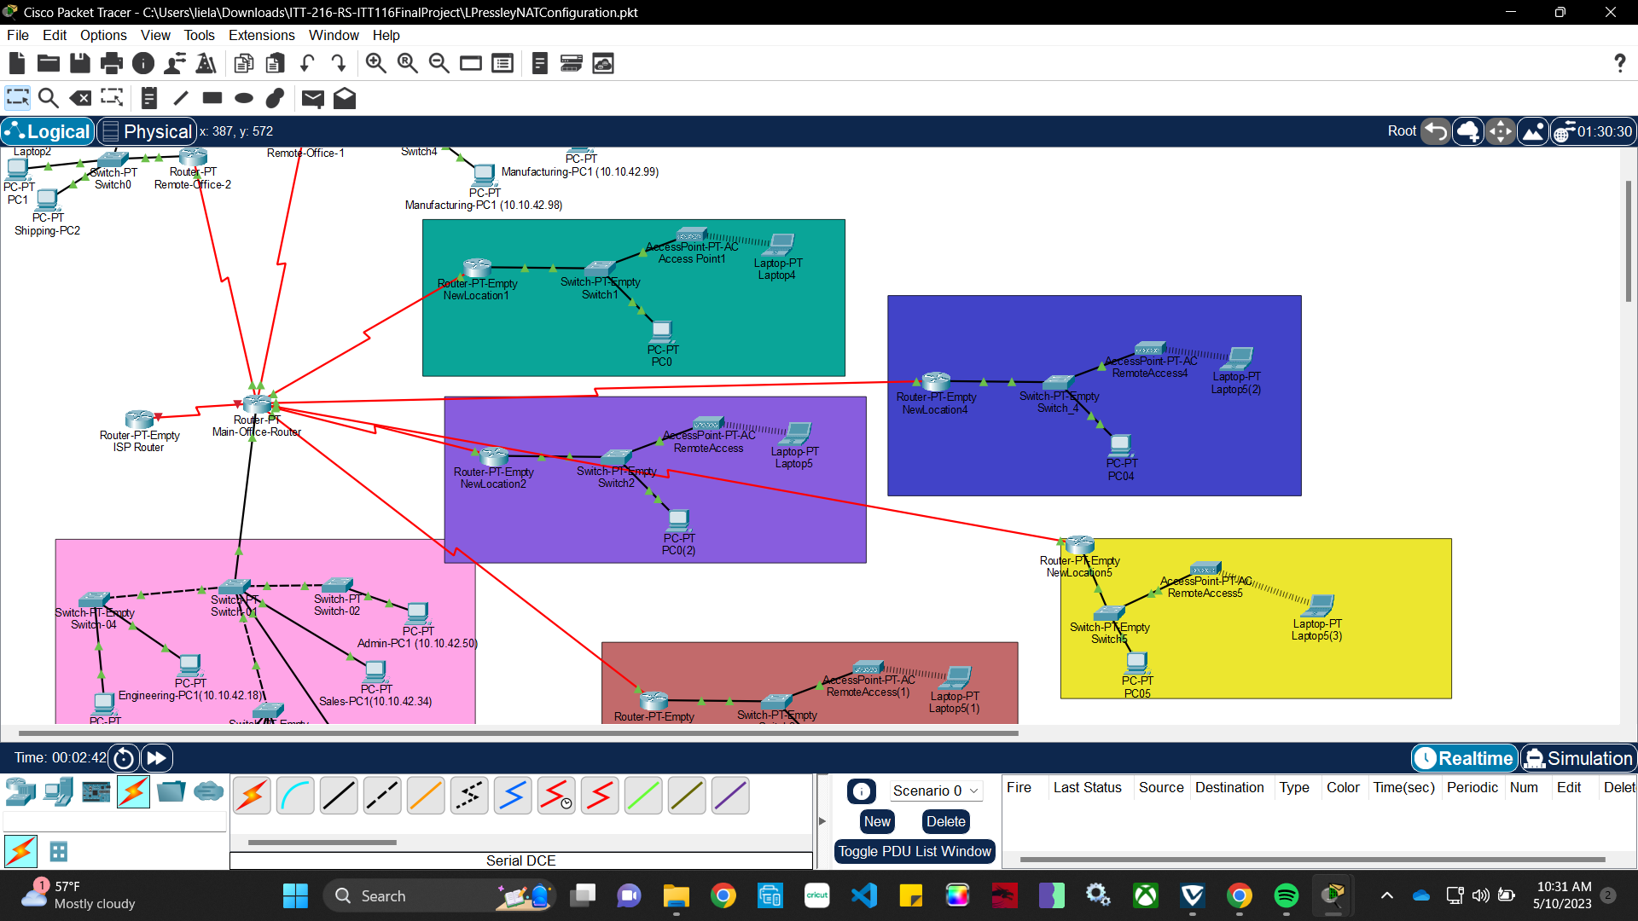
- Configure bgp, neighbor, and ip routes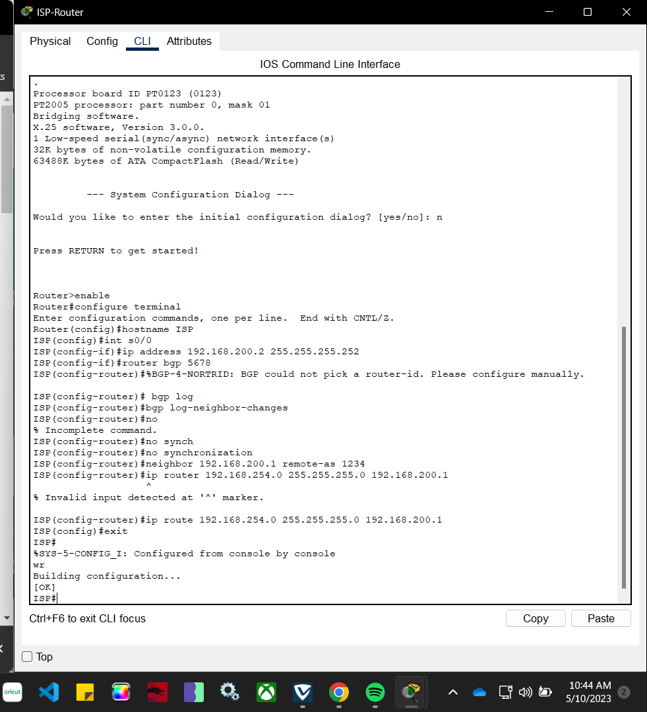
- Configuring NAT for each serial port on main office router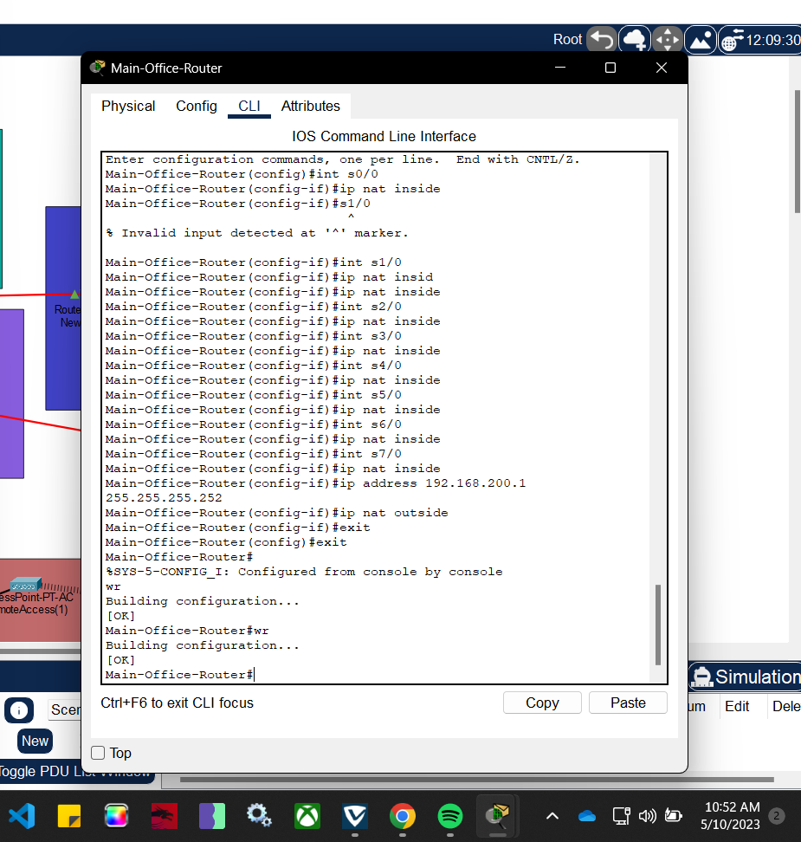
- Setting up the NAT pool on the main office router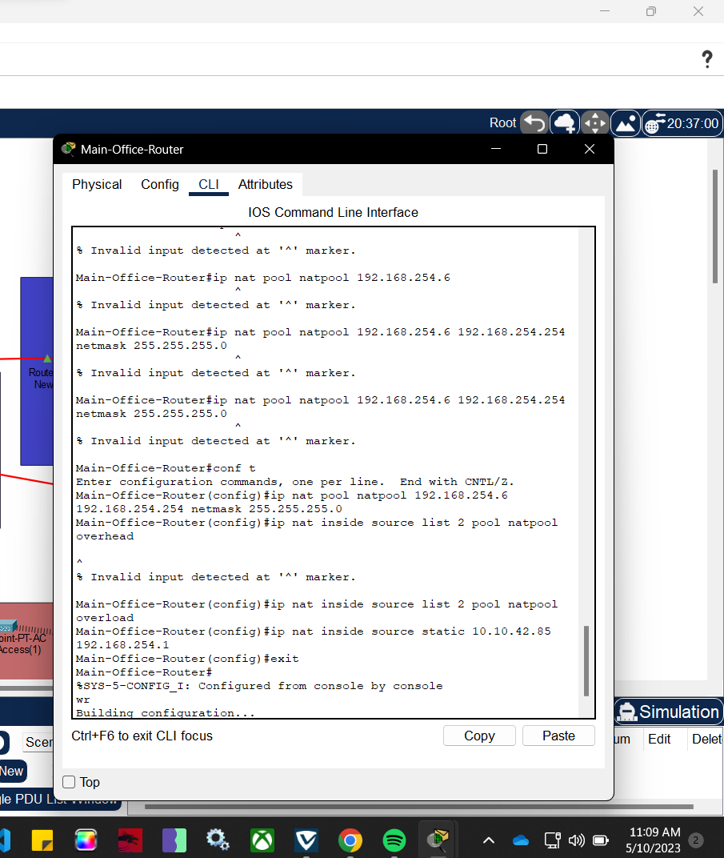
- Can view inside and outside NAT translations